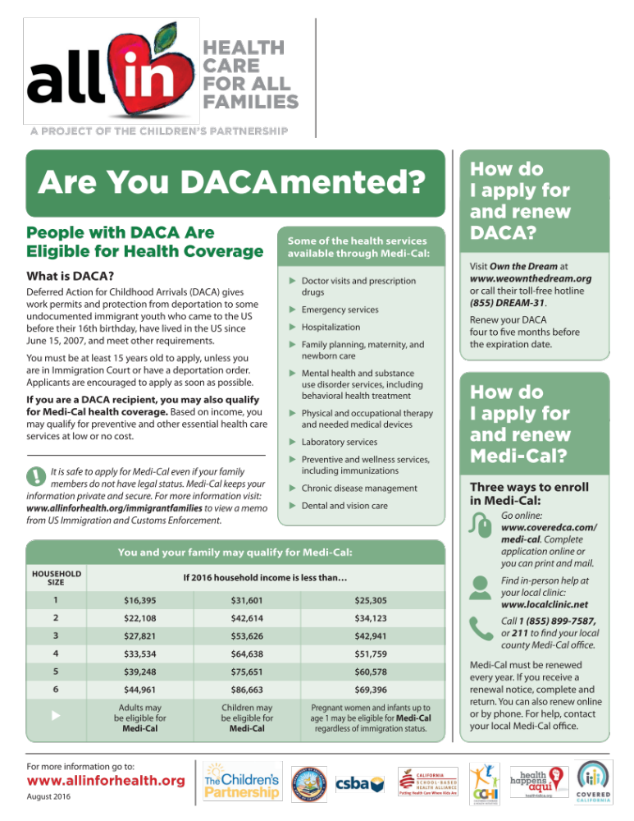
Use this customizable text and logo area to enter local information.

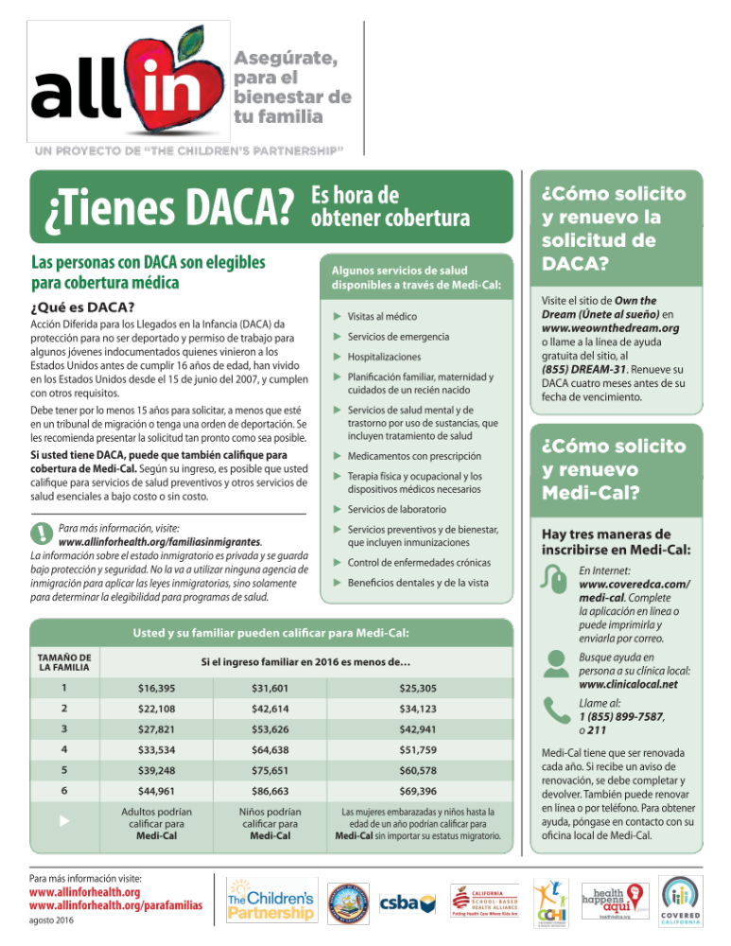
Use this customizable text and logo area to enter local information.

