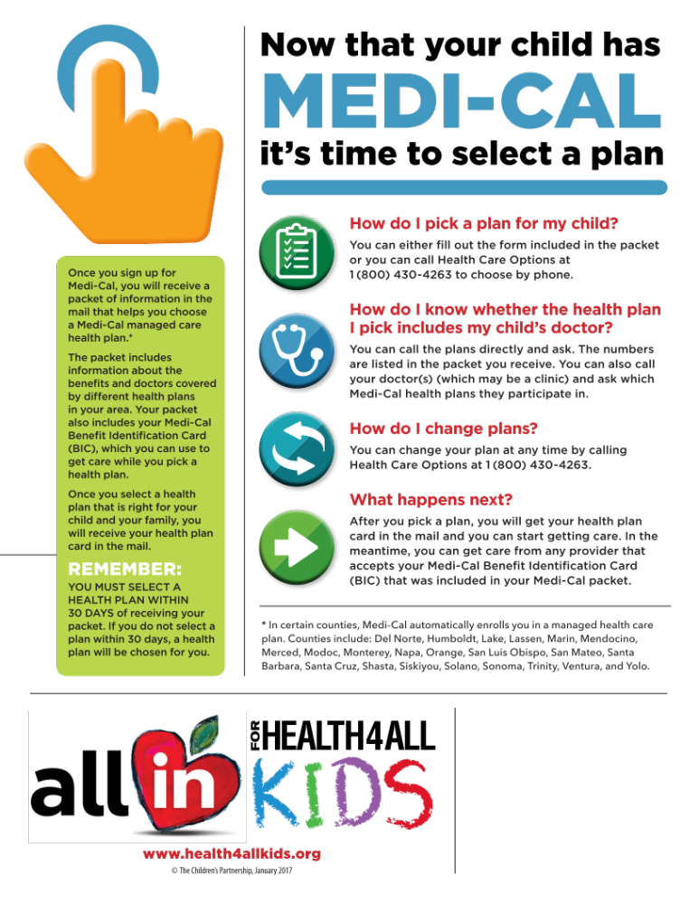

Use this customizable text and logo area to enter local information.
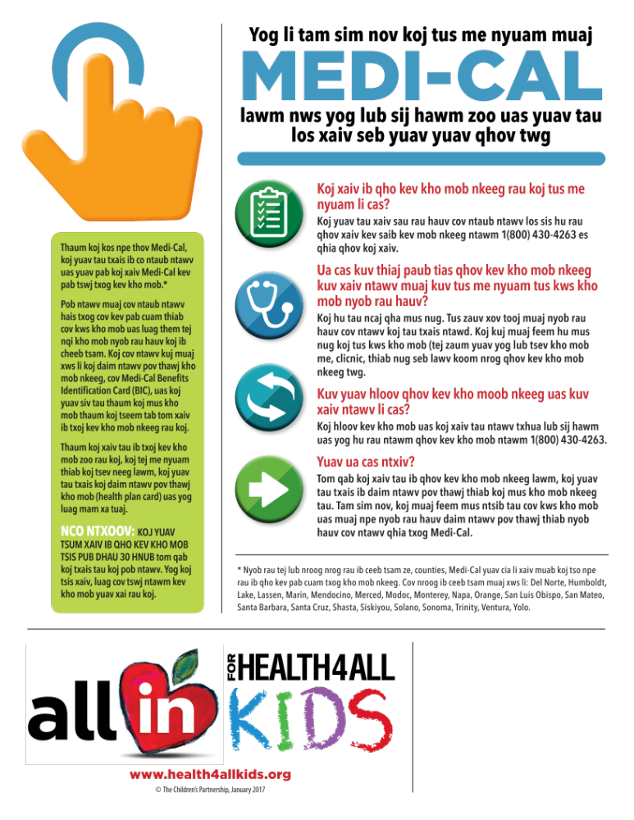
Use this customizable text and logo area to enter local information.

