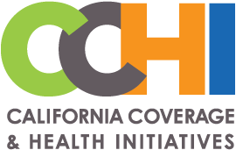 |  | 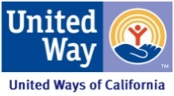 |  | 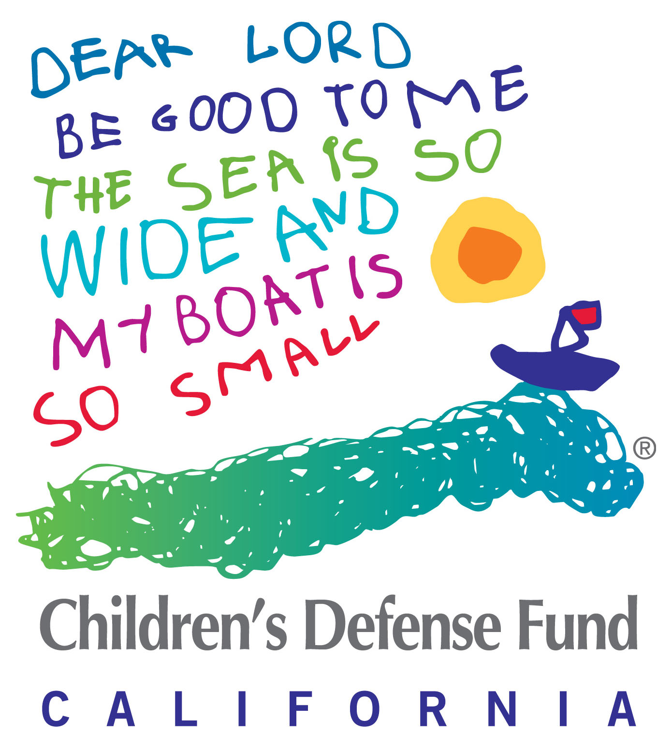

TAKE ACTION: CONGRESS NEEDS TO FUND CHIP NOW!
The Children’s Health Insurance Program (CHIP) provides affordable, pediatric-appropriate health coverage to nearly 9 million children nationwide, including 2 million children and pregnant women in California. Yet despite broad bipartisan support, Congress neglected to take action to extend CHIP funding before it expired on September 30th.

The good news: Both House and Senate committees approved strong bills to fund CHIP. The Senate Hatch-Wyden KIDS bill (S. 1827) and House HEALTHY KIDS bill (H.R 3921) contain similar CHIP policies:
1) 5-year CHIP funding;
2) Enhanced CHIP match rate through 2019 with a one-year phase down before returning to the regular CHIP match rate in 2021;
3) Maintenance of effort (MOE) protection continued for children with incomes at or below 300% FPL; and
4) Extension of Express Lane Eligibility, demonstrations and outreach programs.

The bad news: Progress toward passing CHIP funding has stalled because there is not yet a bipartisan agreement on how to pay for CHIP funding.

California is currently spending down the last of its remaining CHIP allocation ($2.7 billion in 2017), which is projected to run out in December.

There is no such thing as “safely delaying” action on CHIP. The consequences of Congress’ delay are happening already, with stressful uncertainty for states and families across the country and, some states preparing to send out notices to children and pregnant women (not yet in California) about terminated or modified coverage. Enrollment freezes and coverage disruptions have long term chilling impacts on enrollment.

California is developing contingency plans: Our state will soon need to decide whether to continue its coverage for the pregnant women and infants under the CHIP-funded Medi-Cal Access Program. In addition, when California’s CHIP funding runs out later this year, the state will be confronted with a huge budget gap for CHIP children’s Medi-Cal coverage: State financing will need to fill in the federal funding shortfall between the CHIP match rate assumed in state budget (65%) and Medicaid (50%).

MESSAGE TO CONGRESS: Congress must pass CHIP funding NOW.
- California families need to be able to rely on CHIP without constant fear that their children’s coverage is at risk. (CHIP/Medicaid numbers by district).
- The CHIP policy contained in both the House and Senate bills is good policy and bipartisan. Now Congress must finish the job and pay for it in a bipartisan way that does not harm children and families.
- California is currently preparing its budget for FY 2019 and needs certainty about the future of CHIP with specific federal funding levels.
- We do not want to see the tremendous coverage gains for children over the past two decades put at risk due to Congressional delays.

ACTION ITEMS
1) Contact our Senators and Representatives. Either call them in DC or meet with members in their district to urge them to pass CHIP funding immediately.

2) Contact Local Media. Urge local health care reporters to be asking California’s congressional representatives why they have not passed CHIP funding. Ask local editorial boards to urge Congress to immediately fund CHIP.

3) Advocate to #ExtendCHIP on social media. Join the social media CHIP conversation using the sample social media posts & graphics.

3) Share family stories. Identify stories of how families will be impacted without CHIP funding. Providers can explain how Congress’ inaction impacts the health, well-being, and access to care of your patients? Email us (below) if you have a story. Reporters and legislators would find those stories very useful.

For this Action Sheet, CHIP social media images and resources listed below, please go to:
http://health4allkids.org/toolsfororgs/childrens-health-insurance-program-chip/
California Snapshot, Q&A document, Mayor letter, Kaiser bill comparison

Ktesta@childrenspartnership.org; modeh@childrennow.org; abuist@childrensdefense.org; jdarnell@unitedwaysca.org

